Task 1 – Foundations & Environment Setup

Lab Setup Report
Intern: SUMANTH UPPALA
Program: Cybersecurity & Ethical Hacking Internship, ApexPlanet Software Pvt. Ltd.
Timeline: Days 1–12
Report Date: 29-10-2026

1. Objective
To build strong fundamentals in cybersecurity, networking, and cryptography, and to set up a professional, isolated penetration-testing lab for use throughout the remainder of the internship.

2. Cybersecurity Basics
CIA Triad
- Confidentiality – ensuring information is accessible only to those authorized to see it.
- Integrity – ensuring information is accurate and has not been tampered with.
- Availability – ensuring systems and data are accessible to authorized users when needed.
Threat Types Studied: Phishing, Malware, DDoS, SQL Injection, Brute Force, Ransomware.
Attack Vectors Studied: Social Engineering, Wireless Attacks, Insider Threats.
[1–2 sentences in your own words: which of these felt most relevant/interesting and why]

3. Lab Environment Setup
Hypervisor: VirtualBox / VMware (circle or state which)
Virtual Machines Configured:
VM | Role | IP (Host-Only)
Kali Linux | Attacker machine | 192.168.56.3
Metasploitable2 | Target machine | 192.168.56.3
Network Mode: Host-Only Adapter (isolated lab network — no traffic leaves the host)
📸 Screenshot 1: VirtualBox/VMware Manager showing both VMs listed and powered on [insert image here]
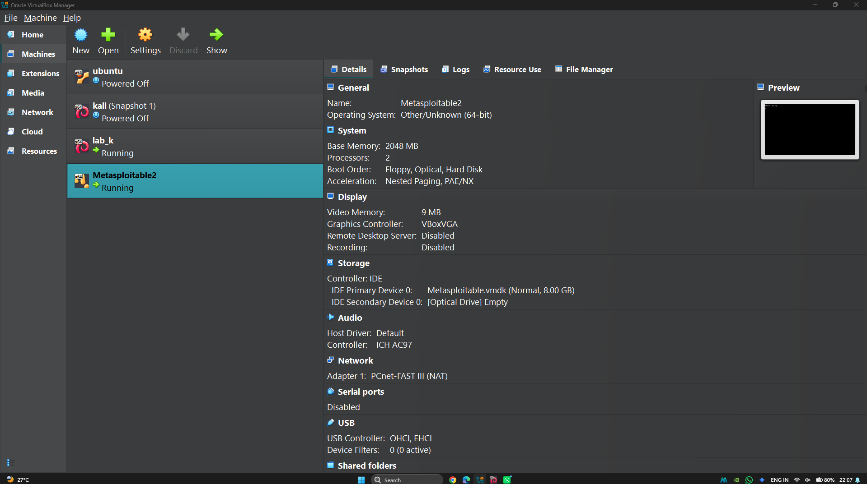
📸 Screenshot 2: Host-Only Adapter network configuration screen [insert image here]
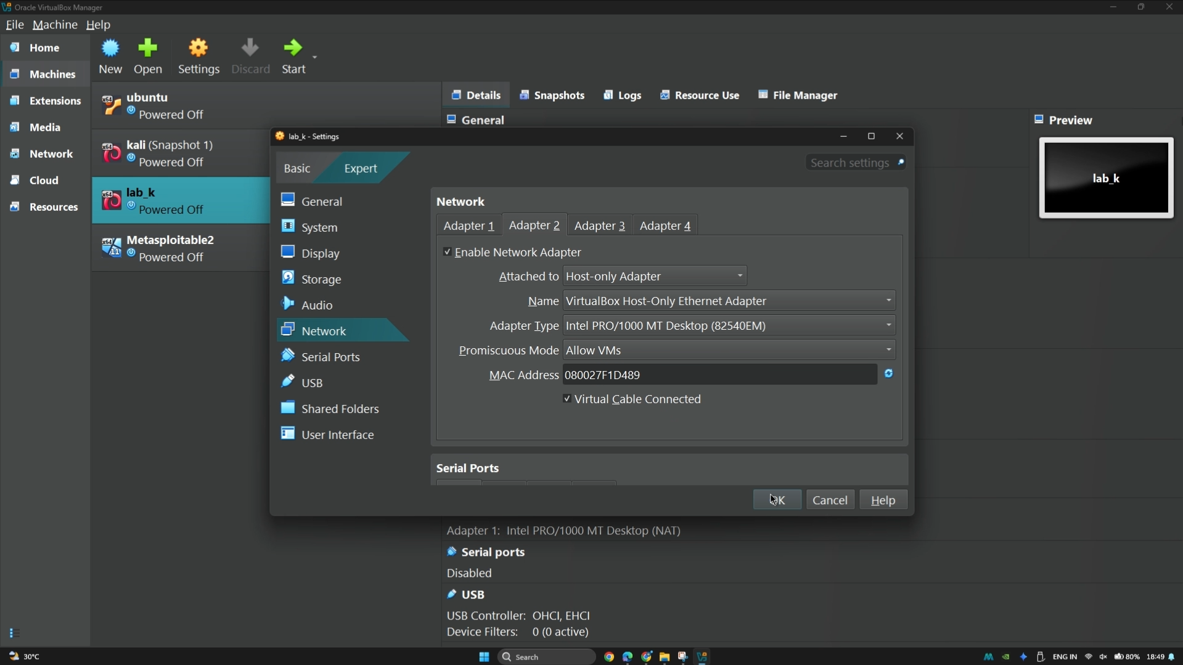
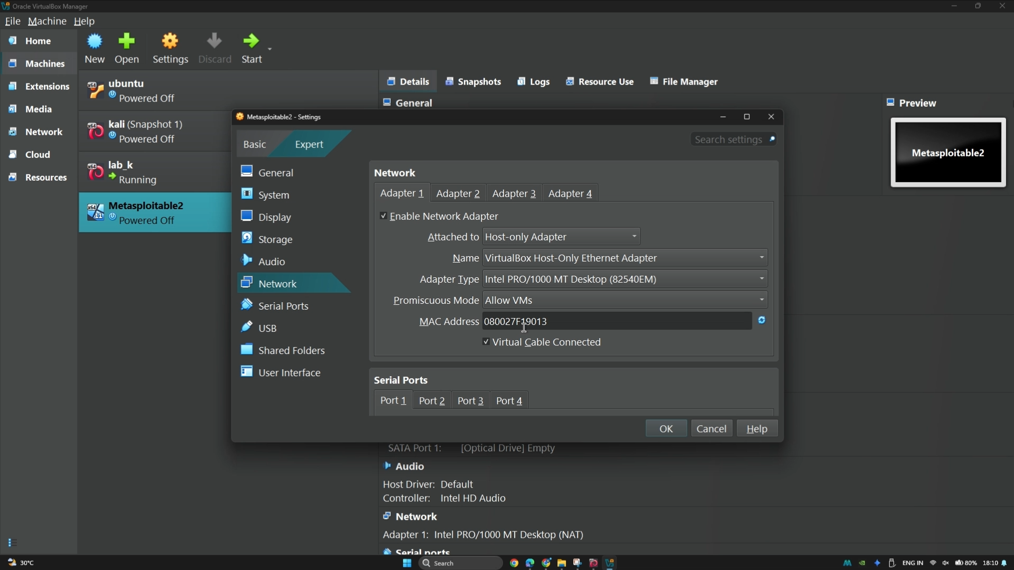
📸 Screenshot 3: Kali Linux desktop after successful boot [insert image here]
(No separate desktop screenshot was captured — shown below instead: host-only network connectivity confirmed with a ping test between the Kali attacker machine and the Metasploitable2 target.)
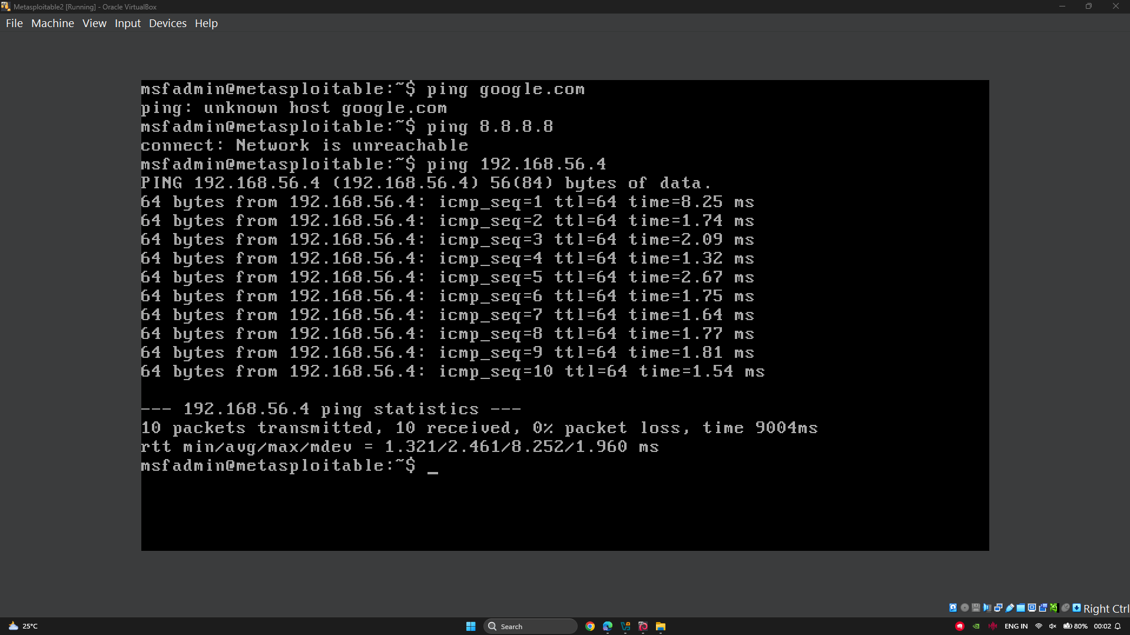

4. Linux Fundamentals
Commands practiced on Kali Linux:
Category | Commands
File navigation | cd, ls, pwd
Permissions | chmod, chown
Package management | apt, dpkg
Networking | ifconfig, ping, netstat, traceroute
📸 Screenshot 4: Terminal output of ifconfig, ping, and traceroute [insert image here]
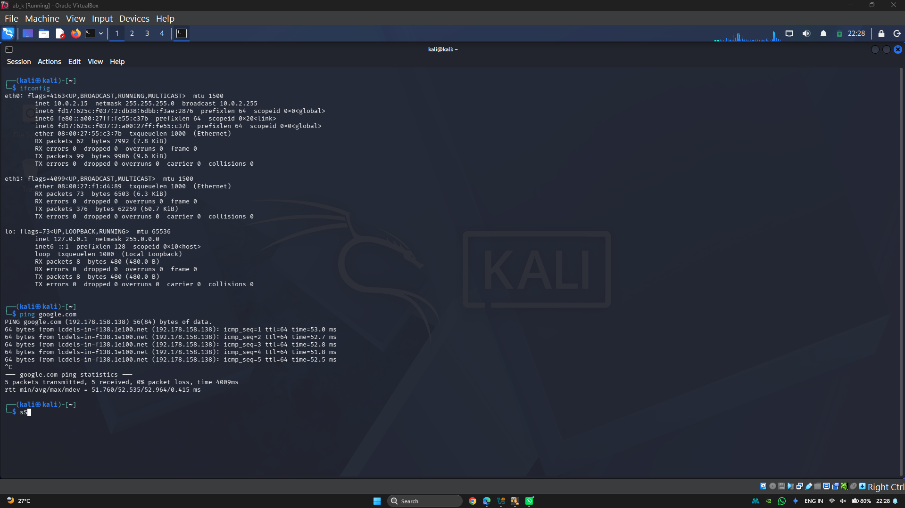
📸 Screenshot 5: Terminal output of a chmod/chown permission change [insert image here]
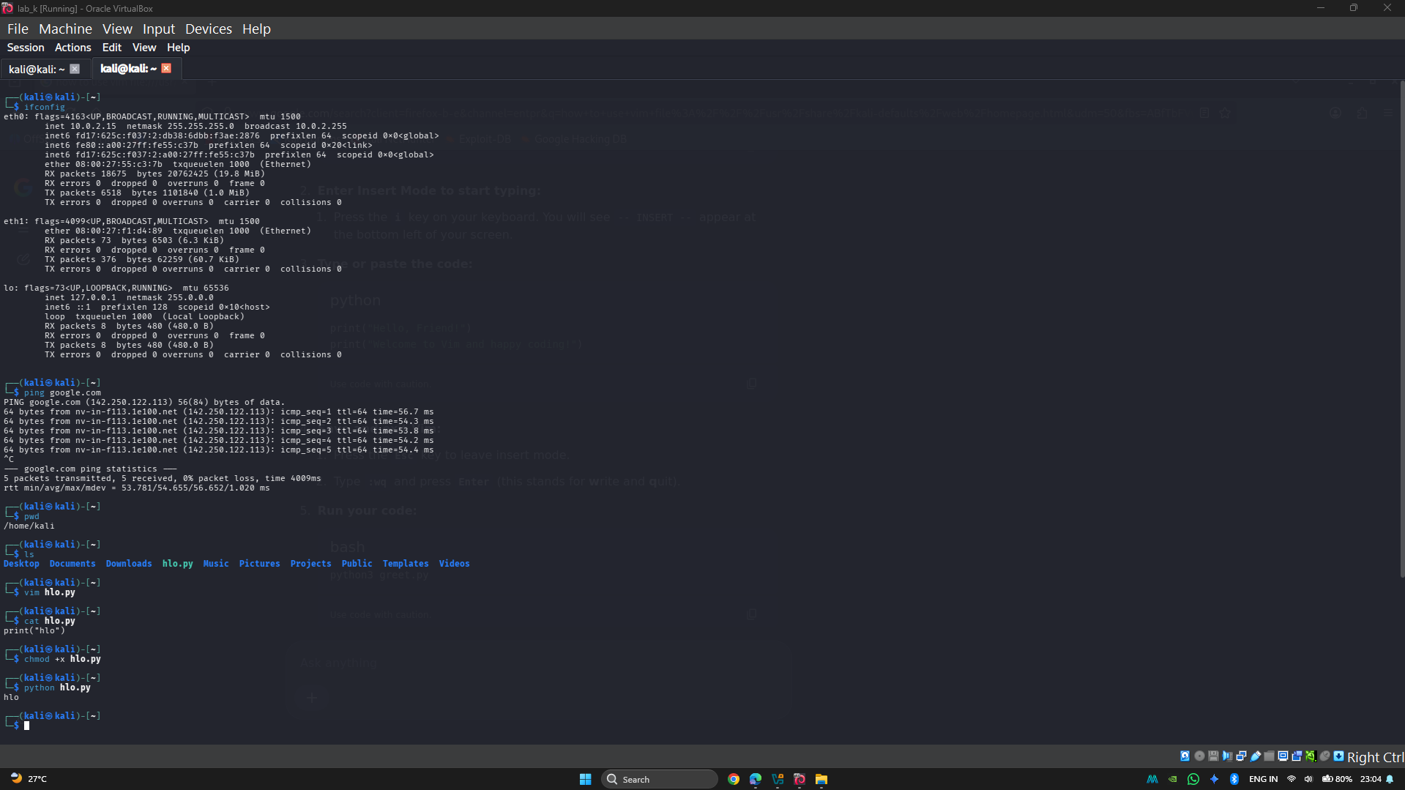
📸 Screenshot 6: Terminal output of an apt/dpkg install [insert image here]
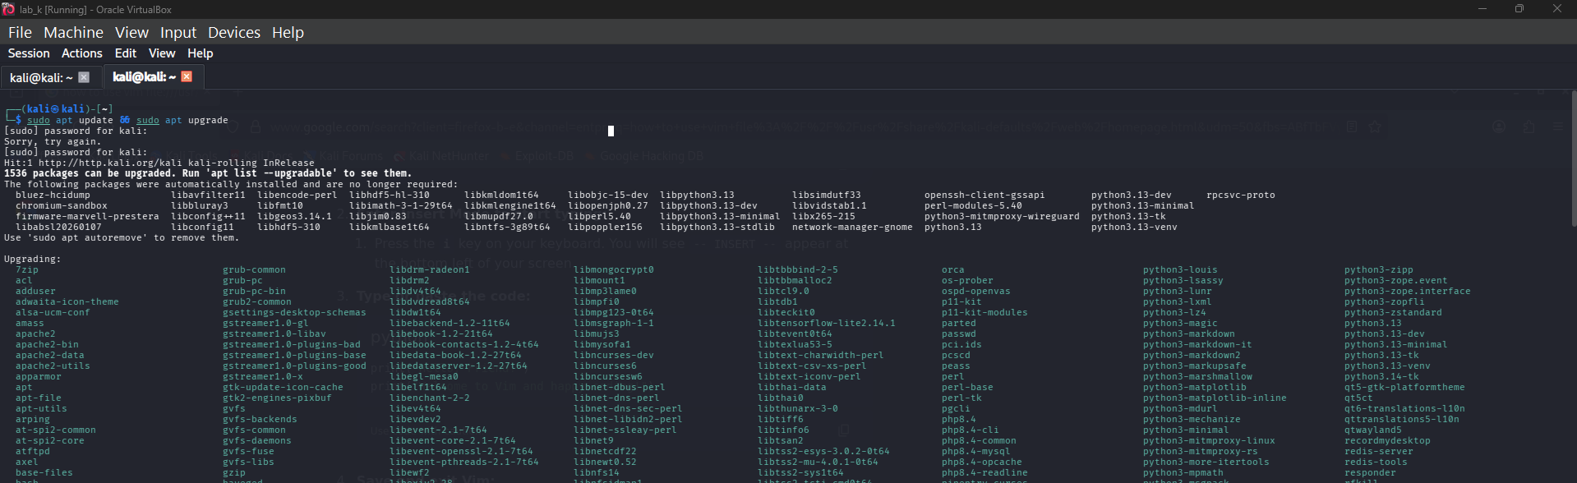

5. Networking Basics
- OSI Model – 7 layers (Physical → Application) describing how data moves across a network.
- TCP/IP Suite – the practical 4-layer protocol stack the internet actually runs on.
- DNS & HTTP/HTTPS – how names resolve to addresses, and how web traffic is requested/secured.
- IP Addressing, Subnetting, NAT – how devices are identified and how private networks reach the public internet.
[2–3 sentences summarizing what you learned about how these layers connect to the attacks you'll study in Task 2]

6. Cryptography Basics
- Symmetric vs Asymmetric Encryption – shared-key vs public/private-key approaches.
- Hashing (MD5, SHA256) – one-way fingerprints used for integrity checks.
- Digital Certificates & SSL/TLS – how trust is established for encrypted web traffic.
Hands-on: Encrypted and decrypted a test message using OpenSSL.
📸 Screenshot 7: OpenSSL encryption command + output [insert image here]
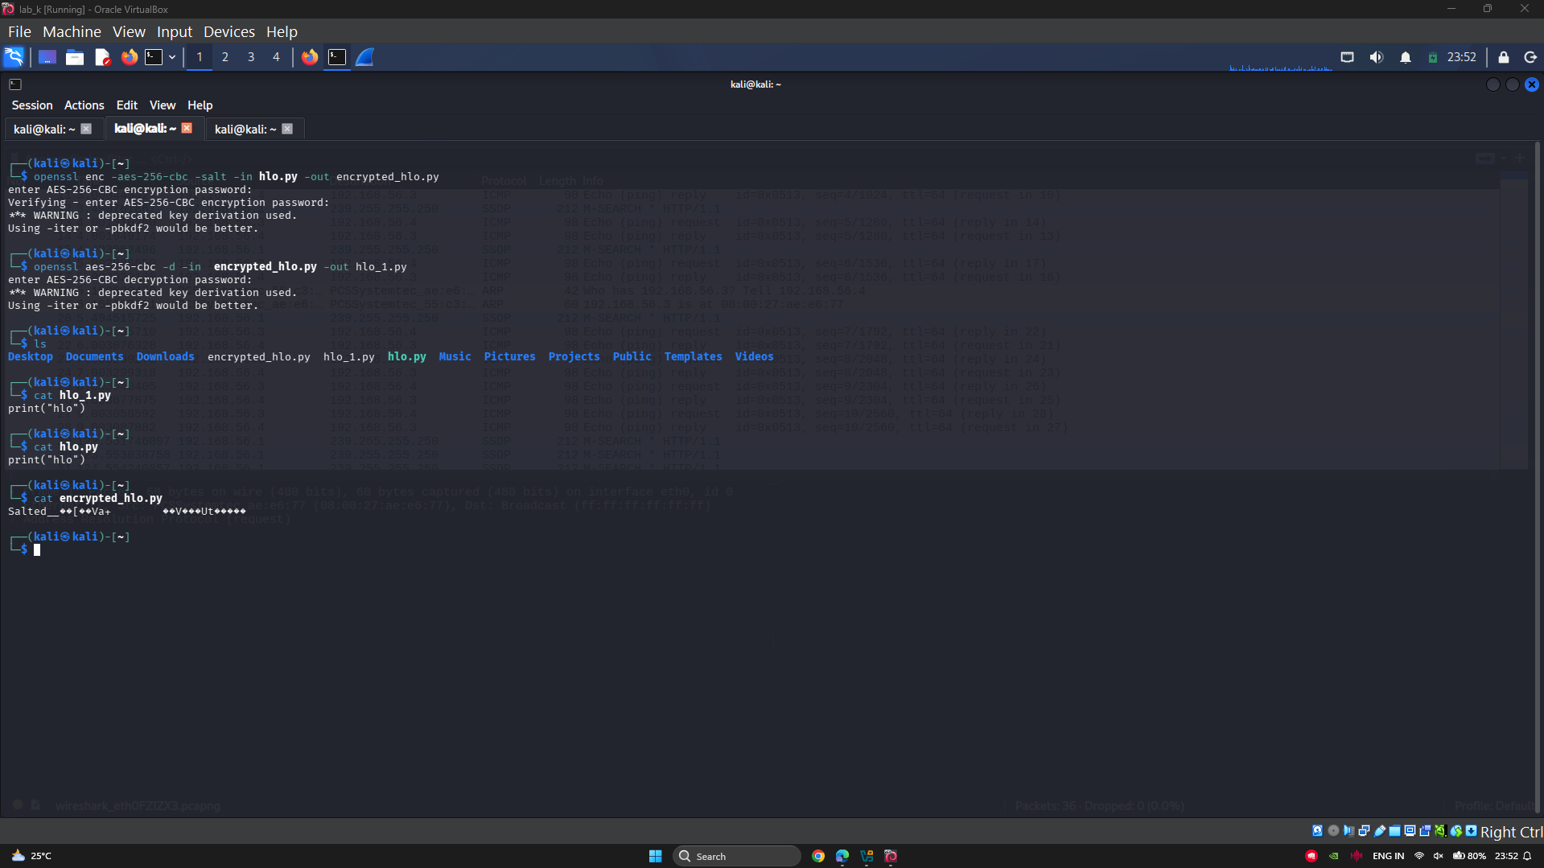
📸 Screenshot 8: OpenSSL decryption command + output (recovering the original message) [insert image here]
(Covered in Screenshot 7 above — the same terminal output shows both the encryption and decryption commands in sequence.)

7. Tool Familiarization
Tool | Purpose | Verified Working
Wireshark | Packet capture/analysis | ☐
Nmap | Network/port scanning | ☐
Burp Suite | Web proxy/intercept | ☐
Netcat | Network debugging | ☐
📸 Screenshot 9: Wireshark with a test packet capture open [insert image here]
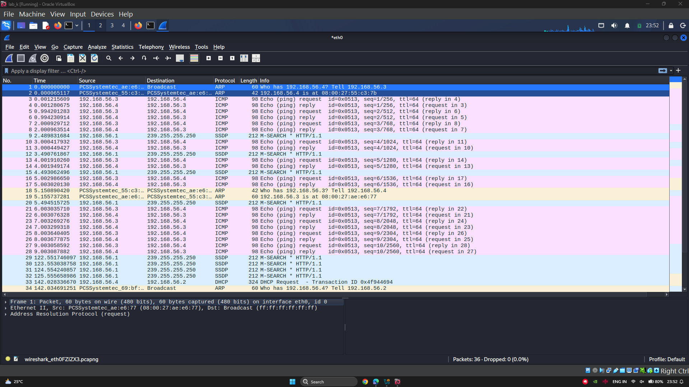
📸 Screenshot 10: Nmap, Burp Suite, and Netcat each opened/running [insert image here]
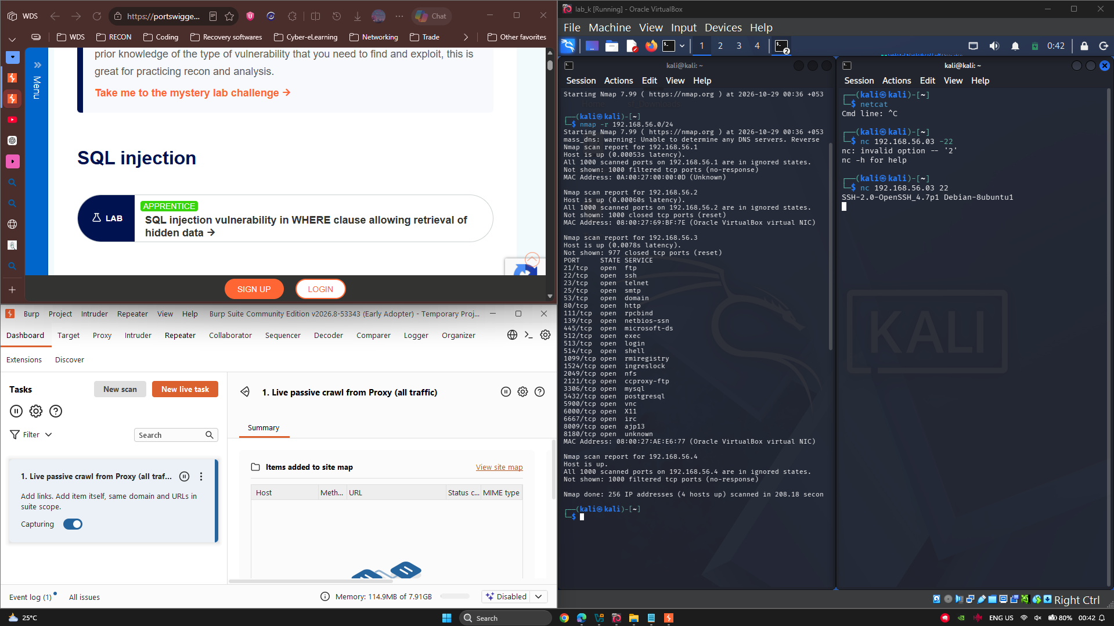

8. Challenges & Learnings
Challenges: Configuring the dual-adapter network in VirtualBox caused IP assignment conflicts and interface naming confusion between eth0 and eth1, which initially blocked two-way communication between Kali Linux and Metasploitable 2.
Learnings: I learned how to assign static IPs manually using Linux ip tools, manage DHCP leasing on Host-Only networks, and isolate network traffic safely without needing external internet access.

9. Conclusion
The lab environment (Kali Linux attacker machine + Metasploitable2 target machine, isolated via Host-Only networking) is fully operational and ready for the scanning and exploitation work in Tasks 2–5. Core Linux, networking, and cryptography fundamentals were reinforced through hands-on practice rather than theory alone.

10. Uploaded file links
- GitHub Repo link: Cybersecurity-Ethical-Hacking-ApexPlanet/Task-1-Foundations at main · suman-git74/Cybersecurity-Ethical-Hacking-ApexPlanet
- Lab Setup Report (in repo)
- Linux cheat-sheet (in repo)
- 5-min video walkthrough link: https://lnkd.in/p/dB4Tr_m4

